Deliverable 8 – User Training Materials
Enhancing Security in Messaging Applications
Spinnaker Analytics
29 June 2026

Table of Contents
- Introduction
- Secure Account Setup
- Using Secure Messaging
- Secure Voice & File Sharing
- Privacy Best Practices
- Recognizing Security Threats
- Troubleshooting Security Features
- Frequently Asked Questions (FAQ)
- Security Awareness Checklist
- Conclusion

1. Introduction

1.1 Purpose
- This document provides guidance for users and administrators on securely using the messaging application.
- It explains recommended security practices, authentication methods, secure communication features, privacy protections, and troubleshooting steps to help users maintain the confidentiality and integrity of their communications.

1.2 Learning Objectives
- After completing this guide, users should be able to:
  - Configure a secure account
  - Enable Multi-Factor Authentication (MFA)
  - Verify contacts using safety numbers
  - Send encrypted messages and files
  - Participate in secure voice calls
  - Recognize phishing attempts
  - Report security incidents

2. Secure Account Setup

2.1 Account Registration
- Users should:
  - Create a strong password
  - Enable MFA
  - Register a trusted device
  - Keep recovery information up to date

2.2 Password Requirements
Requirement | Recommendation
Minimum Length | 12 Characters
Complexity | Uppercase, lowercase, numbers, symbols
Password Reuse | Not Allowed
Password Manager | Recommended

2.3. Secure Accounts
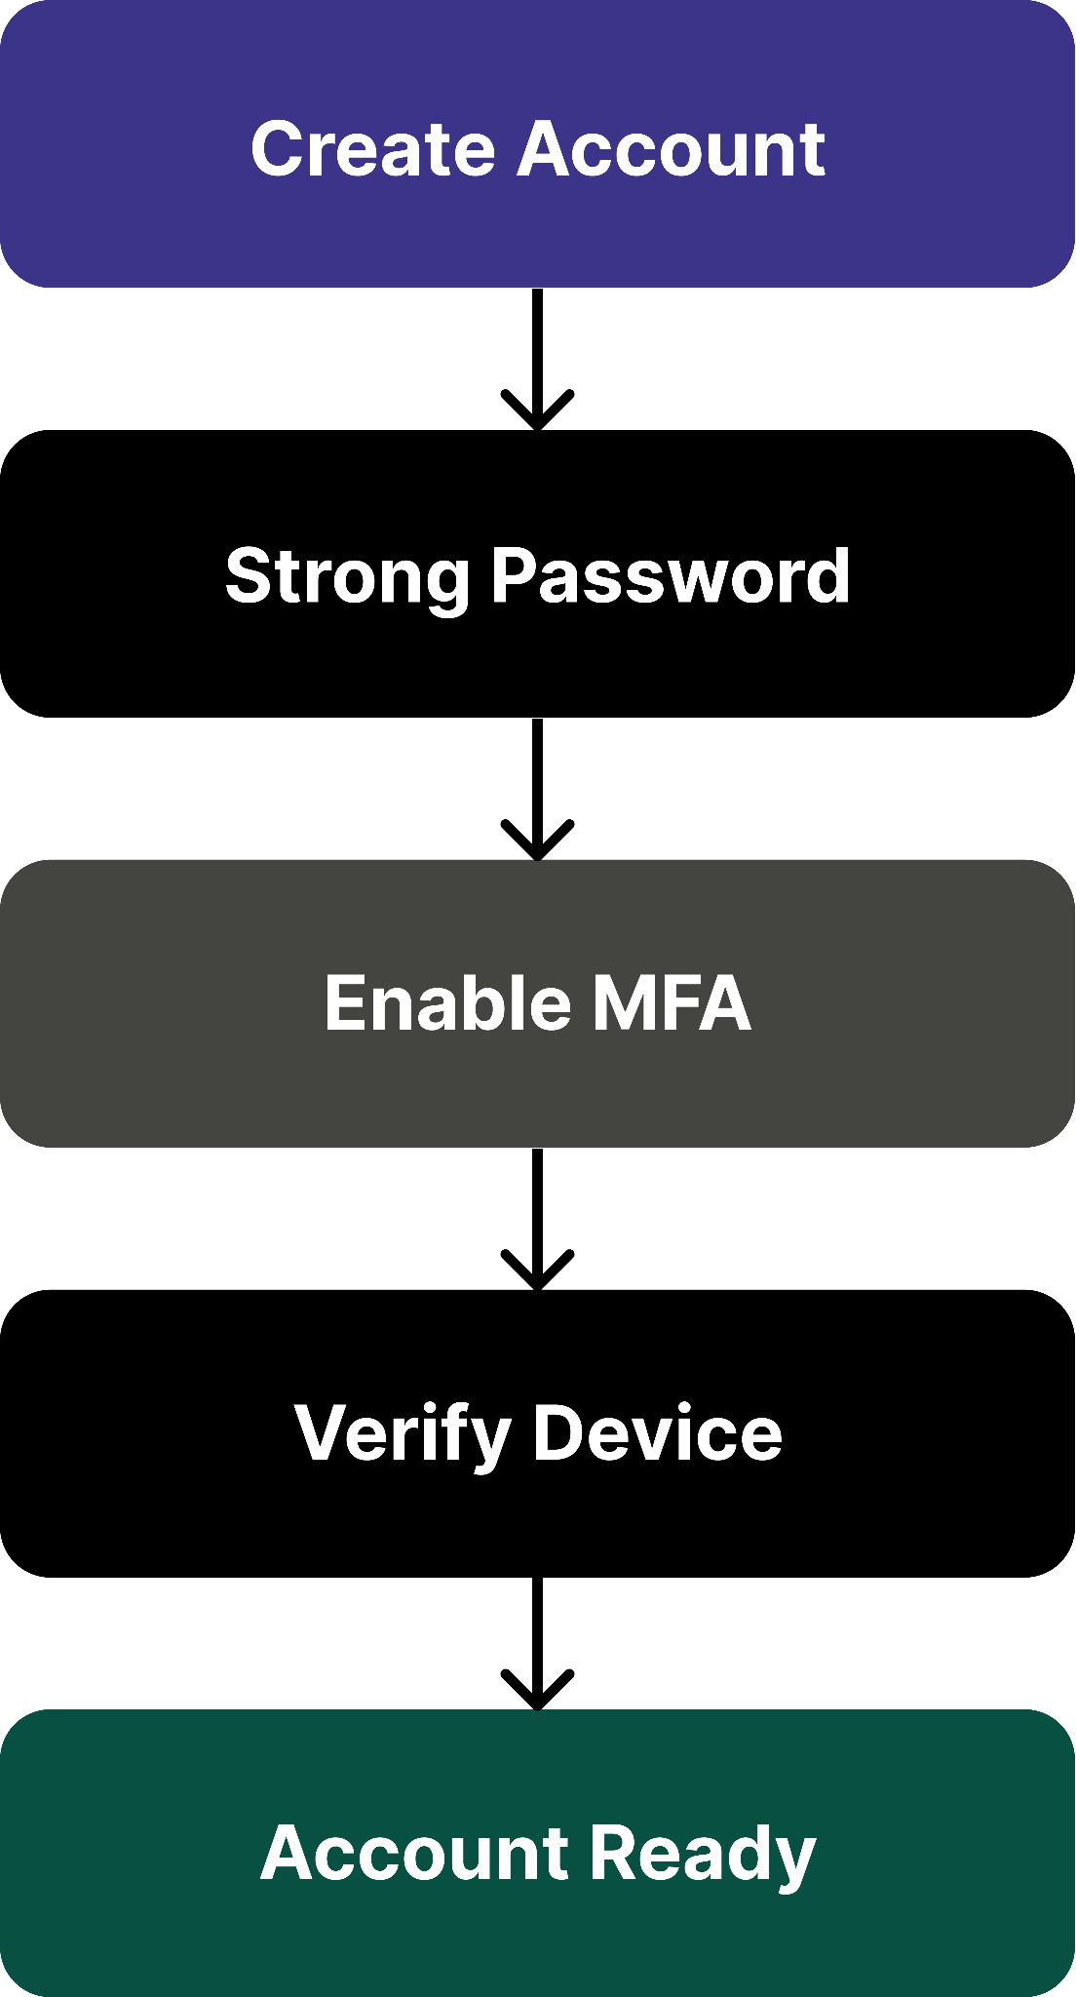

3. Using Secure Messaging
- Messages are automatically protected using end-to-end encryption.
  - Users should:
    - Verify recipient identity
    - Confirm safety numbers when available
    - Avoid sending sensitive information to unknown contacts
    - Update the application regularly

3.1 Message Security Features
Feature | Purpose
End-to-End Encryption | Message confidentiality
Message Authentication | Prevent tampering
Forward Secrecy | Protect previous conversations
Secure Key Rotation | Continuous protection

3.2 Secure Messaging

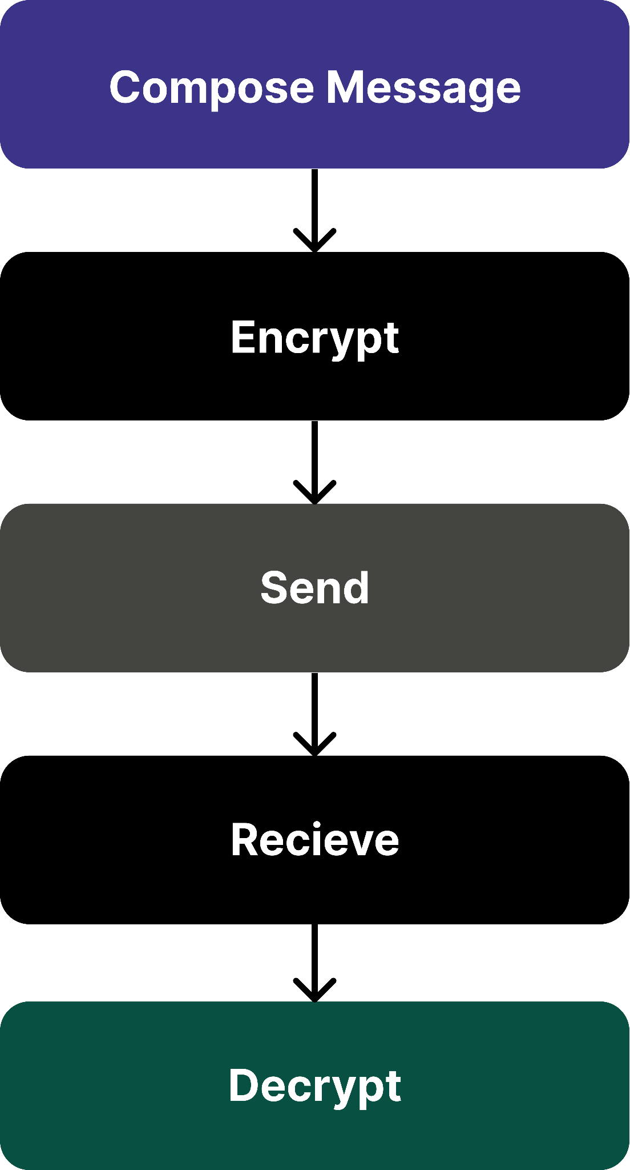

4. Secure Voice & File Sharing

4.1 Voice Calls
- Users should:
  - Verify recipient identity
  - Use trusted networks when possible
  - Avoid discussing sensitive information over speakerphone
  - Update the application before important calls

4.2 File Sharing
- Before sharing files:
  - Verify recipient
  - Scan files for malware
  - Avoid executable attachments
  - Share only necessary information

4.3 File Sharing Checklist
Check | Status
Recipient Verified | Yes
File Scanned | Yes
Sensitive Data Reviewed | Yes
Correct File Selected | Yes

4.4 secure File Sharing
Figure 39 – Secure File Sharing Workflow
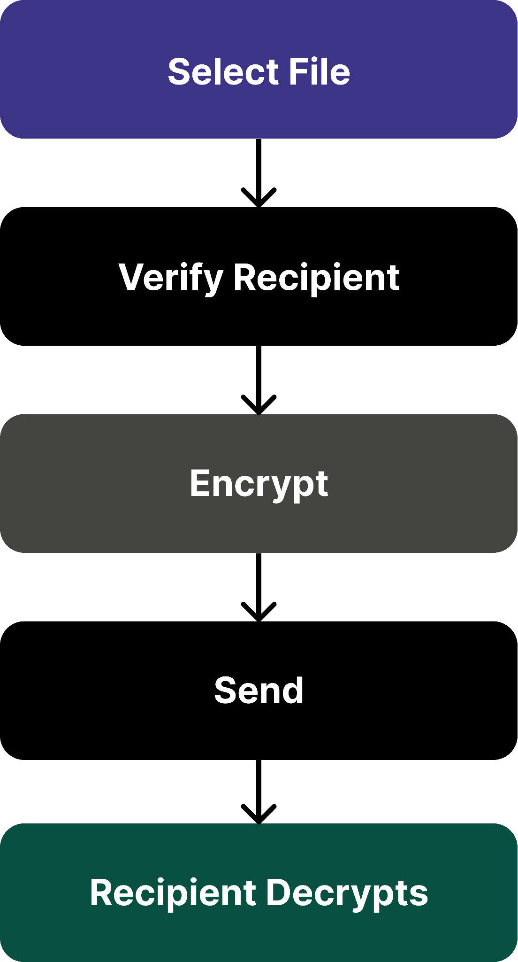

5. Privacy Best Practices
- To maintain privacy:
  - Lock your device with a PIN or biometric authentication.
  - Never share verification codes or passwords.
  - Keep the application updated.
  - Review connected devices periodically.
  - Delete unnecessary files and conversations.
  - Log out from unused devices.

Do | Don't
Enable MFA | Share passwords
Verify contacts | Click unknown links
Lock your device | Disable updates
Use trusted networks | Install untrusted apps

5.1 Privacy Checklist
Practice | Recommended
Device Lock | Yes
Biometric Authentication | Yes
MFA Enabled | Yes
Automatic Updates | Yes
Screen Lock Timeout | Short

6. Recognizing Security Threats
Users should recognize common threats.

6.1 Phishing
- Warning signs:
  - Unexpected login requests
  - Urgent payment requests
  - Unknown links
  - Fake support messagess

6.2 Malware
- Indicators:
  - Unexpected application behavior
  - Battery drain
  - Excessive network activity
  - Unauthorized permissions

6.3 Social Engineering
- Examples:
  - Impersonation
  - Fake customer support
  - QR code scams
  - Credential harvesting

6.4 Threat Recognition
Figure 40 – Threat Recognition Process Workflow
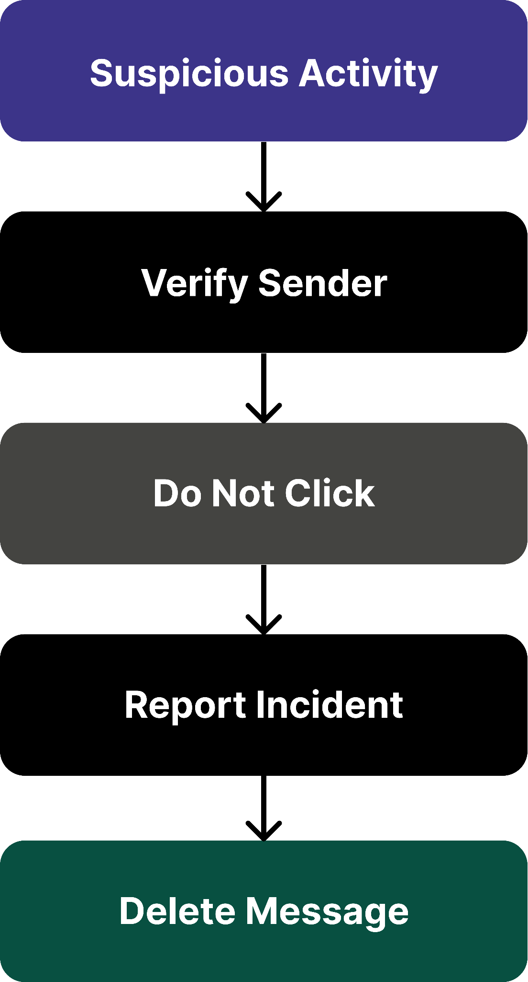

7.Troubleshooting Security Features

7.1 Common Issues
Issue | Resolution
MFA Code Not Working | Verify device time
Unable to Verify Contact | Refresh safety number
Login Failure | Reset password
Certificate Warning | Do not proceed; report issue
Failed Secure Call | Update application and retry

7.2 Reporting Security Incidents
- Users should report:
  - Lost devices
  - Suspicious messages
  - Unauthorized login alerts
  - Possible phishing attempts
  - Application crashes affecting security

8. Frequently Asked Questions (FAQ)
- Q1. Are my messages encrypted?
  - Yes. Messages are protected using end-to-end encryption, ensuring only the intended recipient can read them.
- Q2. Can the server read my messages?
  - No. The server routes encrypted messages and stores only the minimum metadata required for service operation.
- Q3. Why should I enable MFA?
  - MFA provides an additional layer of protection even if your password is compromised.
- Q4. What should I do if I lose my phone?
  - Immediately revoke the device, change your password, and contact the administrator if applicable.
- Q5. Are voice calls encrypted?
  - Yes. Voice calls are protected using secure real-time encryption.

9. Security Awareness

9.1 Daily Security Checklist
Task | Complete
Device Locked | ( Yes/No )
MFA Enabled | ( Yes/No )
Software Updated | ( Yes/No )
Unknown Links Avoided | ( Yes/No )
Sensitive Files Verified | ( Yes/No )
Suspicious Activity Reported | ( Yes/No )

9.2 User Security
Figure 41 – User Security Awareness Cycle
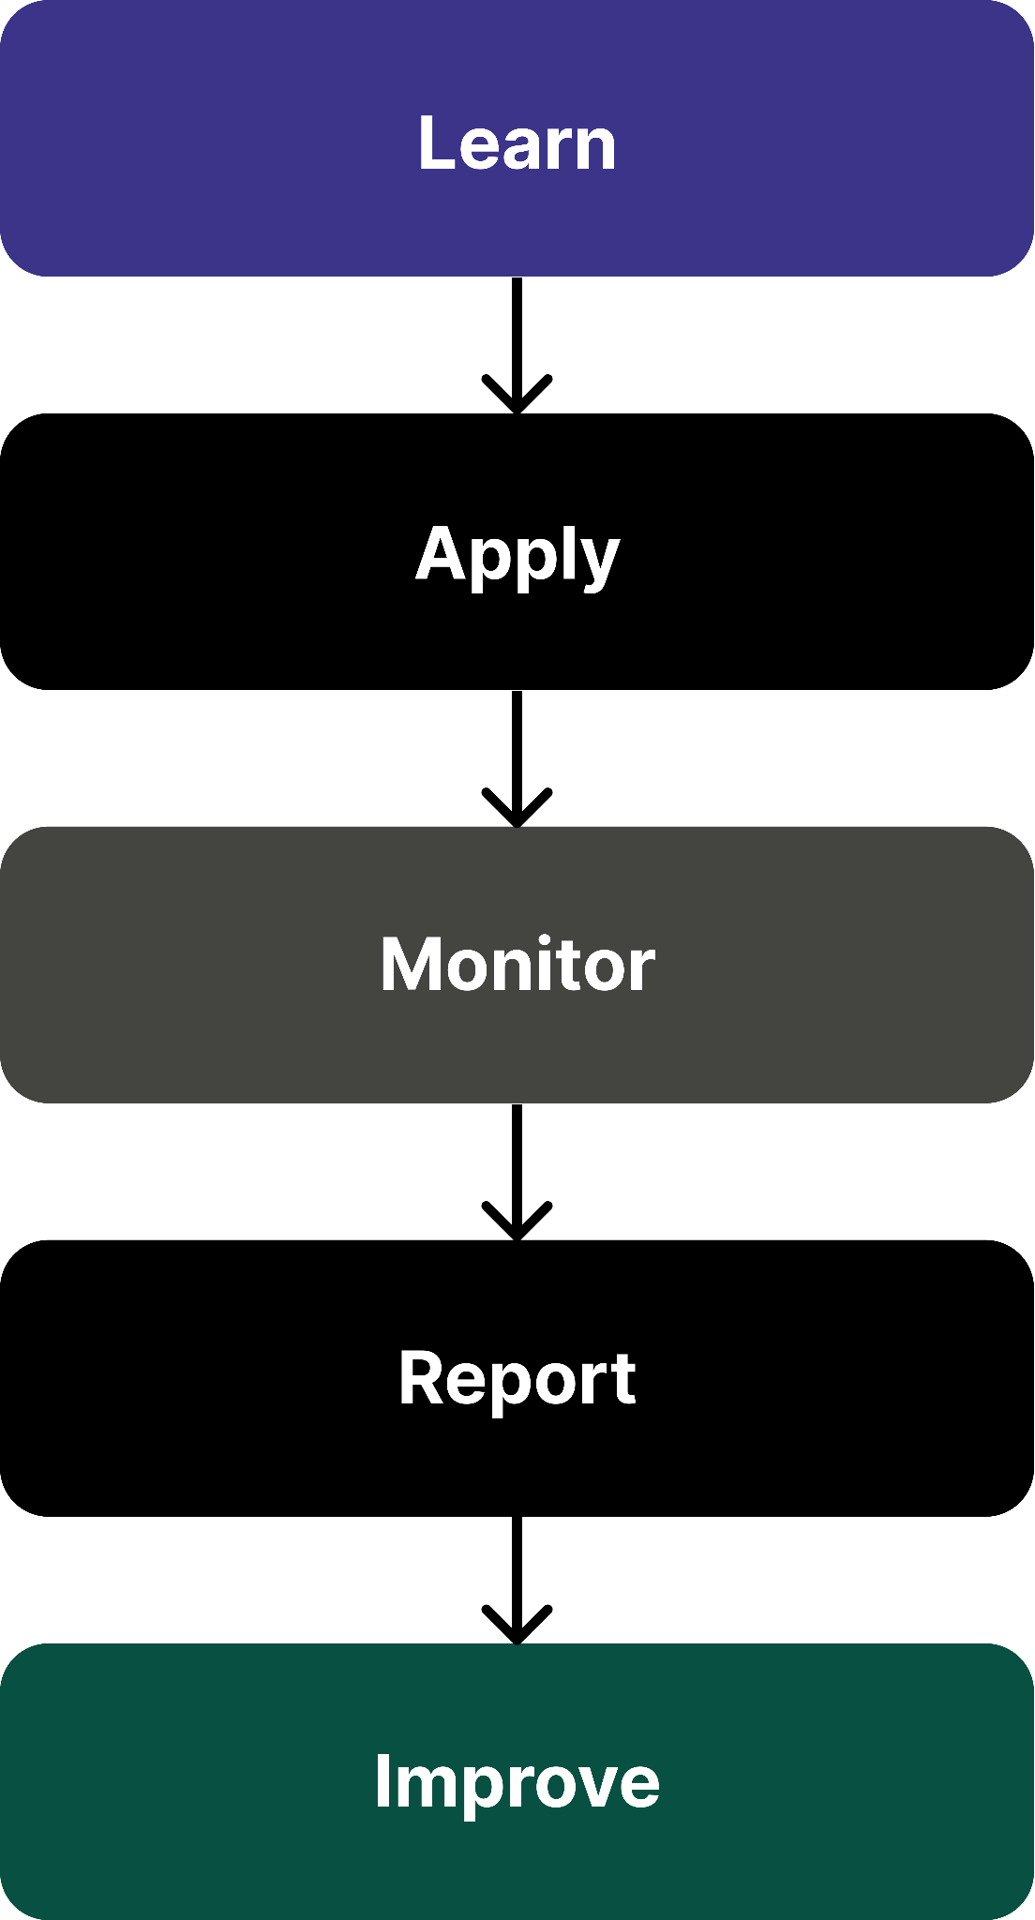

10. Conclusion
- This User Training Guide provides practical instructions for securely using the messaging application.
- By following the recommended practices for authentication, encrypted messaging, voice calls, file sharing, and privacy protection, users can significantly reduce the risk of unauthorized access, phishing, malware, and data exposure.
- Ongoing awareness and adherence to security best practices remain essential to maintaining a secure communication environment.

